TECHNICAL SPECIFICATION
for participation in Procurement ID No. 24022026-01

No. | Equipment name | Quantity | TECHNICAL SPECIFICATION
Lot No. 1
Include delivery, installation, commissioning and personnel training.
1.1 | Semi-Automatic Basket Unloading Line | 1 | Semi-automatic basket unloading line for automatic discharge of jars from autoclave baskets onto the packaging/labeling conveyor.  - Automatic jar unloading from autoclave baskets  - Line capacity: 9,000 units/hour  - Top unloading (basket height: 1168 mm)  - Jars transferred to labeling line conveyor  Jar dimensions:  (Diameter and height as specified in original table)  Basket dimensions:  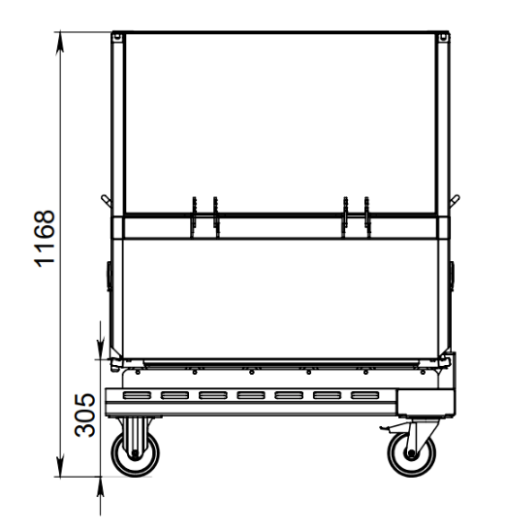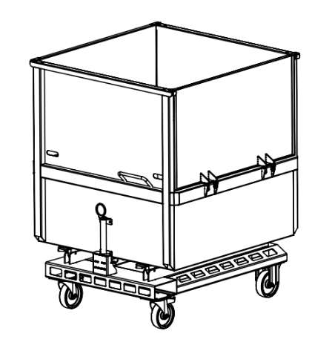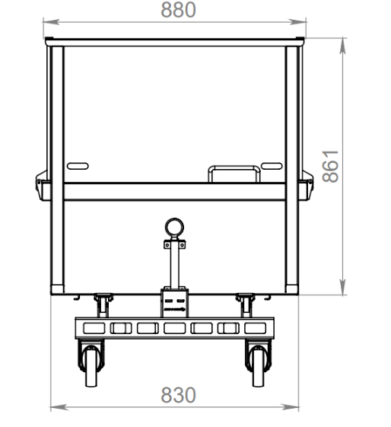  Utilities required: electricity and compressed air.  Include delivery, installation, commissioning and personnel training.
  No. | Jar name | Jar dimensions
   |  | Diameter height
  1 | Jar 130ml (PT51) | 60,5 | 69,7
  2 | Burka 190ml (PT51) | 61+/-1,3 | 98+/-1
  3 | Burka 200ml (PT51) | 60+/-1,3 | 106,8+/-1
  4 | Burka 200ml (TO66) | 70+/-1,4 | 75+/-1
  4 | Burka 200ml (TO66) | 69,5 | 75,5
  5 | Burka 220ml (PT51) | 60,9 | 108,5
  6 | Burka 240ml (TO66) | 71+/-1,4 | 90+/-1
  7 | Burka 240ml, 250g (PT51) | 61+/-1,3 | 115+/-1
  8 | Burka 265ml (TO66) | 71,5+/-1,4 | 104,8+/-0,8
  9 | Burka 380ml (TO66) | 73+/-1,4 | 124+/-1
  10 | Bottle 0.250 l (TO43) | 62,5+/-1,3 | 137,8+/-1,2
  10 | Pudele 0.250 l (TO43) | 62,5+/-1,2 | 137,8+/-0,8
  11 | Pudele 0.3 l (TO43) | 61,2+/-1,2 | 181+/-1,3
  11 | Pudele 0.5 l (TO43) | 75,+/-1,4 | 216+/-1,5
  12 | Pudele 0.5 l (TO43) | 74,5+/-1,4 | 212+/-1,5
1.2. | Glass Container Dryer | 1 | The equipment is designed to blow off moisture from glass containers after the sterilization process. Blowing process: with the help of air knives, which are placed at an angle to ensure the removal of water droplets from the glass container.  The arrangement of the air knives is adjustable, which allows them to be adapted to each type of container. The design is easy to move and easy to service.  - Equipment productivity up to 9000 pcs./h (150pcs/min)  - Belt speed (adjustable) 0.25 m/s  - Using appropriate pipelines, valves, connecting elements, wires, etc., ensure connection to communications for the following energy carriers: compressed air (from the compressor room); electricity (from the electrical switchboard).  Include delivery, installation and training.
1.3. | X-Ray Inspection System for Glass Packaging | 1 | Purpose: detection of foreign bodies with higher absorption density than product.  - Detection of glass, stone, metal contaminants in filled containers  - Reject verification system  - Capacity: minimum 9,000 units/hour  - Conveyor speed: minimum 1.0 m/s  Include delivery, installation and training.
1.4. | Labeling Machine | 1 | - Simultaneous application of 3 labels:  - Main label  - Label-on-label  - Neck label  OR  - Main label  - Label-on-label  - L-shaped tamper-evident label (from cap to glass)  - Capacity: 9,000 units/hour  - Compressed air and electrical connections required  Include delivery, installation and training.
1.5. | Inkjet Coding Printer | 1 | • Non-contact printing  • Minimum 3 print lines  • Automatic printhead cleaning  • IP53 protection  • Up to 3 lines (25 dot height), logos, barcodes, batch coding, real-time coding  • 60-micron nozzle  • 3 m umbilical  • Stainless steel housing  • Ink reservoir: 1.2 L  • Solvent reservoir: 1.2 L  • Ink resistant to autoclave conditions  • Stainless steel frame (AISI 304), keyboard height 1100 mm.
1.6. | Vacuum detector | 1 | Closed container inspection. Checks whether there is a vacuum in the closed container. Ensuring a productivity of at least 150 pieces/minute. The equipment is designed for PT51 and TO43-80 lids. New communications will be created to ensure the operation of the equipment: electricity, compressed air.  Include delivery, installation, installation, personnel training.
Lot No. 2
2.1. | Automatic Packaging and Shrink-Wrapping Line | 1 | - Automatic cardboard tray feeding and jar placement  - Integrated shrink tunnel  - Mechanical width adjustment system (max 4 adjustment points)  - Film format change via control panel  Max dimensions:  - Length ≤ 10 m  - Width ≤ 1.6 m  - Height ≤ 2.5 m  Air consumption: 20 Nl per cycle at 6 bar.
No. | Jar name | Jar dimensions |  | TRANSPORT PACKAGING - in thermal film
No. | Jar name | Diameter mm | heigh mm | Number of units in the package | cardboard stand is/not | sticker on the transport packaging | Stikera Sticker position on the transport packaging
1 | Burka 130ml (PT51) | 60,5 | 69,7 | 6 | is | is | on top or on the side
2 | Burka 190ml (PT51) | 61+/-1,3 | 98+/-1 | 6 | is | is | on top or on the side
3 | Burka 200ml (PT51) | 60+/-1,3 | 106,8+/-1 | 6 | is | is | on top or on the side
4 | Burka 200ml (TO66) | 70+/-1,4 | 75+/-1 | 6 | not | is | on top or on the side
4 | Burka 200ml (TO66) | 70 | 75 | 12 | is | is | on top or on the side
4 | Burka 200ml (TO66) | 69,5 | 75,5 | 6 | is | is | on top or on the side
5 | Burka 220ml (PT51) | 60,9 | 108,5 | 6 | is | is | on top or on the side
6 | Burka 240ml (TO66) | 71+/-1,4 | 90+/-1 | 6 | not | is | on top or on the side
6 | Burka 240ml (TO66) | 71+/-1,4 | 90+/-1 | 6 | is | is | on top or on the side
7 | Burka 240ml, 250g (PT51) | 61+/-1,3 | 115+/-1 | 6 | is | is | on top or on the side
8 | Burka 265ml (TO66) | 71,5+/-1,4 | 104,8+/-0,8 | 6 | is | is | on top or on the side
9 | Burka 380ml (TO66) | 73+/-1,4 | 124+/-1 | 6 | not | is | on top or on the side
9 | Burka 380ml (TO66) |  |  | 12 | is | is | on top or on the side
10 | Pudele 0.250 l (TO43) | 62,5+/-1,3 | 137,8+/-1,2 | 6 | is | is | on top or on the side
10 | Pudele 0.250 l (TO43) | 62,5+/-1,3 | 137,8+/-1,2 | 6 | not | is | on top or on the side
11 | Pudele 0.3 l (TO43) 171731 Ketchup_O-I | 61,2+/-1,2 | 181+/-1,3 | 6 | no | is | on top or on the side
11 | Pudele 0.5 l (TO43) 175278 Ketchup_O-I | 75,+/-1,4 | 216+/-1,5 | 6 | is | is | on top or on the side
11 | Pudele 0.5 l (TO43) 175278 Ketchup_O-I | 75,+/-1,4 | 216+/-1,5 | 6 | not | is | on top or on the side
11 | Pudele 0.5 l (TO43) 175278 Ketchup_O-I | 75,+/-1,4 | 216+/-1,5 | 12 | is | is | on top or on the side
12 | Pudele 0.5 l (TO43) SE00905006057 Ketchup_Vetropack | 74,5+/-1,4 | 212+/-1,5 | 6 | not | is | on top or on the side
12 | Pudele 0.5 l (TO43) SE00905006057 Ketchup_Vetropack | 74,5+/-1,4 | 212+/-1,5 | 6 | is | is | on top or on the side
12 | Pudele 0.5 l (TO43) SE00905006057 Ketchup_Vetropack | 74,5+/-1,4 | 212+/-1,5 | 12 | is | is | on top or on the side

2.2. | Pallet Wrapper | 1 | • Adjustable top and bottom wrapping cycles  • Photoelectric pallet height detection  • Turntable speed: 5–10 rpm (frequency-controlled)  • Load capacity ≥ 1000 kg  • Turntable diameter: 1650 mm  • Wrapping height: 2100 mm  • Film tension: electromagnetic brake  • Max load size: 1200 x 1000 mm  • Power supply: 230V / 50 Hz
2.3. | Screw-Type Air Compressors | 2 | The compressor is designed to provide uniform, sufficient air pressure in the existing and new air ducts. Compressor:  - Create connections from two places to the existing air duct line, route length 105m  - Provide 30 air connection points  - Equipped with filters to prevent oil from entering the air system  - Equipped with a system where you can redirect the flow of warm air - indoors in winter, outdoors in summer  - The compressor oil used meets the requirements of the food industry  - Screw-type compressed air compressor  - Nominal electric motor power 22 kW, 400/3/50 V/f/Hz  - Maximum power consumption at full load not more than 28 kW+/-1kw  - Maximum final compression pressure not less than 10 bar+/-0.5bar  - Maximum compressed air output according to ISO 1217 measurement standard not less than 3.2 m3/min.+/- 0.1m3/min  - Noise level not more than 72 dB, according to DIN ISO EN 2151  - The compressor is equipped with anti-freeze protection down to -10C  - The compressor is filled with food grade oil, must be H1S (oil specification must be provided)  - The compressor must be equipped with a remote monitoring system, so that you can remotely (via WEB browser) see the compressor's operating parameters  - Equipped with a frequency converter  - The compressor must be equipped with a built-in freon-type air dryer  - The compressor is equipped with a built-in pressure tank Must be, not less than 500 liters  - The compressor must be equipped with a condensate oil purifier  - The equipment's control panel is touch-sensitive, in Latvian  - The equipment must be manufactured in accordance with the following mandatory provisions: Machinery Directive 2006/42 EC,  Electromagnetic Compatibility Directive 2014/30/EU, RoHS Directive 2011/65/EU  - Also complies with:  Pressure Equipment Directive 2014/68/EU  Low Voltage Directive 2014/35/EU  Simple Pressure Vessels Directive 2014/29/EU  - Equipment must be certified with CE marking  - Equipment dimensions not larger than 2036 x 915 x 1915 h +/-50mm  - Weight not larger than 800 kg +/-5kg
Lot No. 3
3.1. | CIP Station | 1 | 1. Connection of new pipes to the existing CIP pipe ends on the tanks – acid, alkali and reclaimed water tanks  2. Equipment of CIP line No. 2  - Static leg 650 liters 1 pc.  - SolidC-2 5.5 kW 25m3/h 3bars CIP pump 1 pc.  - Slot filter on CIP line No. 2 1 pc.  - Flow meter Siemens DN50 1 pc.  - Concentrated disinfectant dosing station for line 2 1 pc.  - Steam control and steam shut-off valves 1 pc.  - Condensate valves 1 pc.  - Tubular heat exchanger JAD X 5/38 1 pc.  3. Process valves for CIP line No. 2  - Butterfly valves, welding, standard version, automated with control unit and pneumatic drive DN 76.1; DN63.5; DN51; DN25 – 1 set for AWH 316L quality line 2  - Automated diaphragm valve with control unit and pneumatic actuator DN15 - 3 pcs.  - SED 316L quality for dosing concentrated chemicals  - Manual butterfly valves – 1 set for AWH 316L quality line 2 and for updating flow plates  - Pipes, bends, T-joints, couplings – 1 set. 316L quality  4 Equipment for CIP line No. 2  - Temperature probe PT-100 JUMO 1 pc.  - Pressure sensor for level detection in static stem tank 1 pc.  - Cable trays for new CIP sliding line 2 1 pc.  - Electric cables and pneumatic tubes for new CIP line 2 1 pc.  - Flow sensor IFM for line 2 1 pc.  - Conductivity probe Jumo CTI-750 for line 2 1 pc.  5 Control system integration to use two CIP lines simultaneously (existing and new)  - New stainless steel cabinet  - New Siemens PLC S7-1500  - New Siemens HMI 15” Comfort
3.2. | CIP Pipeline to Cooker and Filler | 1 | Build a stainless steel pipe route for chemical equipment washing  12 m to the boiler from the control panel;  The outgoing pipes must have safety valves on top that open only to the specific selected washing line.  24 m to the filler;  Include forward and reverse flow;  Pipe diameter DN51  Include delivery, installation, personnel training.
3.3. | CIP Return Pumps | 2 | Centrifugal pump for pumping washing solution or rinsing water from the buffer tank during the washing process of the equipment:  - Made of stainless steel;  - Minimum output 10 m3/h;  - Motor power not greater than 3kw;  - Using appropriate pipelines, valves, connecting elements, wires, etc., ensure connection to communications for the following energy carriers: electricity (from the electrical distribution cabinet);  - Signal exchange between the pump and the control cabinet is ensured;  - Using appropriate pipelines, valves and connecting elements, ensure that the CIP return water collected (from the small buffer tank) is pumped to the CIP tanks;  Include delivery, installation, and personnel training.
3.4. | Stationary High-Pressure Cleaning System | set | - Pumping station - PUMP STATION PS4 SEE (3x400V/50Hz) or equivalent. Connect the pumping station to the common water network.  - From the pumping station, feed 7 satellites (FOAM SATELLITE S2 F SEE (10-40 bar) or equivalent)  The satellites must have can holders (Can holder 2x30kg 285x700mm or equivalent). It must be possible to wash 2 types of chemicals.  - Using appropriate pipelines, valves, connecting elements, wires, etc., ensure connection to communications for the following energy carriers: water (from the common system), electricity (from the electrical distribution cabinet), signal exchange (between control units and pumps);  - System delivery, installation, connection and personnel training.
Lot No. 4
4.1. | Steam Boiler | 1 | Equipment requirements:  - The equipment is designed for the production of technological steam with a nominal steam production capacity of 8000kg/h  - The equipment must also include all additional equipment for the equipment to operate successfully with natural gas  - The burner, by improving the combustion quality, will reduce the amount of soot (soot reduces efficiency)  - The burner air supply fan is equipped with an ABB frequency converter, which will reduce the boiler house's electricity consumption by at least 50%  - The three-pass boiler is built in such a way that the flames created by the burner, moving through the flue passages in 3 passes, give off their heat as efficiently as possible for the efficient production of steam and, in combination with the ECO3 economizer, the efficiency reaches at least 95%.  - The upper (independent) and lower salt blowdowns of the steam boiler accurately measure the conductivity of the boiler water and thus reduce the boiler's heat losses that occur when blowing off salts.  - a blowdown tank must be installed, where the blown (salty) boiler water is cooled and drained to the sewer  - the boiler feed tank is equipped with a chemical dosing device for oxygen binding and automatic heating of the tank with steam  - the steam line must be connected to the existing steam collector  The offer includes:  - Steam boiler  - Steam boiler equipment  - Water feed tank  - Automation control cabinet  - steam line to autoclaves  - condensate line back to the boiler house  - Start-up and adjustment costs  Installation costs
4.2. | Water Recirculation System | set | - energy saving project with calculations (9 pcs. 6 basket autoclaves);  - transfer the existing system (3 tanks, cooler, pipes, valves, pumps, 2 pcs., 3 basket autoclaves, 2 pcs., 6 basket autoclaves) and supplement the recirculation system;  - supplement 1 tank (volume taking into account the system with 9 pcs. 6 basket autoclaves) - insulated 100mm insulation, material - AISI 304 (t 30C, which ensures storage and reuse of the amount of water consumed by the autoclave);  - inlets to tanks located outside, protected against freezing;  - Pipes connecting the autoclaves to the tanks - material AISI 304;  - Cooling tower equipped with a service platform (installed above the tanks), which cools the water in the tank at 30 C;  - Pumps (8 pcs.) - vertical centrifugal (in line) Equipped with frequency converters, which provide the required water flow;  - Software for pump control;  - Using appropriate pipelines, valves, connecting elements, wires, etc., ensure connection to communications for the following energy carriers: water (between autoclaves and tanks), electricity (from the electrical switchboard), signal exchange (between control units and pumps);  - a heat exchanger integrated into the system, which will provide heat return to the heating and hot water system  - fresh water supply from the water preparation room to the recirculation system and autoclaves;  - System delivery, installation, connection and personnel training.
4.3. | Water Filtration Station | 1 | To supplement the existing water softening system, which will provide an additional 5m3 of water per hour.  System delivery, installation, connection and personnel training.
4.4. | Water Pressure Booster Pumps | set | Pumping station  CO-2MHI1604/ER-UG or equivalent  Nominal speed: 2850 1/min  Max. pumped medium temp.: 70 °C  Ambient temperature: 40 °C  Working pressure: 10 bar  Inlet pressure: 6 bar  Nominal diameters of pipe connections on the suction side: R3  Nominal diameters of pipe connections on the pressure side: R3  Mains connection: 3~230/400 V, 50 Hz  Number of stages: 4  Number of standby pumps: 1  Number of working pumps: 1  Nominal current 3~400 V, 50 Hz: 5.1 A  Pressure boosting system with speed control of the glandless rotor motor for 2 to 4 parallel-connected normally priming high-pressure centrifugal pumps made of stainless steel  Application  - for fully automatic water supply and pressure boosting in industrial systems  - for drinking and domestic water, cooling water, extinguishing water or for pumping water intended for other uses, which does not chemically or mechanically damage the material used in the equipment and which does not contain abrasive or long-fiber components  Integration of the pumping station into the water system;  A water line 70 m D75 from the pumping station was built from PPR material.  Include delivery, installation, personnel training.
Lot No. 5
5.1. | Autoclaves | 3 | - Internal Diameter 1300;  - capacity six baskets;  - 2 doors (one end for basket loading, the other for unloading);  - doors open to the right;  - automatic basket loading and unloading;  - Steam working pressure 6bar (+/- 0.5 bar);  - compressed air working pressure 6 Bar (+/- 0.2 bar);  - electrical connection 380V;  - power does not exceed 8 KW  -the amount of water inside the autoclave does not exceed 600 liters;  - the autoclave has the ability to connect 3 water inlets and 3 water outlet pipes, which ensure the flow of water to the appropriate tanks for water reuse;  - using appropriate pipelines, valves, connecting elements, wires, etc., ensure the connection of autoclaves with communications for the following energy carriers: water (from the room where the pressure boosting pumps are located, material - AISI 304 DN 50/60); steam (from the steam collector AISI 316 DN 114, wall thickness 3mm); compressed air (from the compressor room); electricity (from the electrical switchboard), condensate line (condensate collector and pump) from the autoclaves back to the boiler room AISI 316/304 DN 65/76;  - delivery of autoclaves, installation, connection to communications and personnel training  - integrate the existing autoclave into the overall system;  - integrate cycle reports into the existing system.
5.2. | Autoclave Baskets for Glass Containers | 30 units | Basket for autoclaving glass containers:  - Material AISI 304;  - Wheels for the trolley (wear-resistant plastic), with bearings;  - Small wheels made of material (wear-resistant plastic), which do not deform and can easily push the basket onto the trolley.  - The lower middle part of the basket is separately liftable, does not deform, does not bend. withstands 450kg.  - Equipped with 2 locking pins (one on each side)  - Designed for automatic loading and unloading of jars.  - Smooth inner walls so that jars do not catch and do not damage the lids.  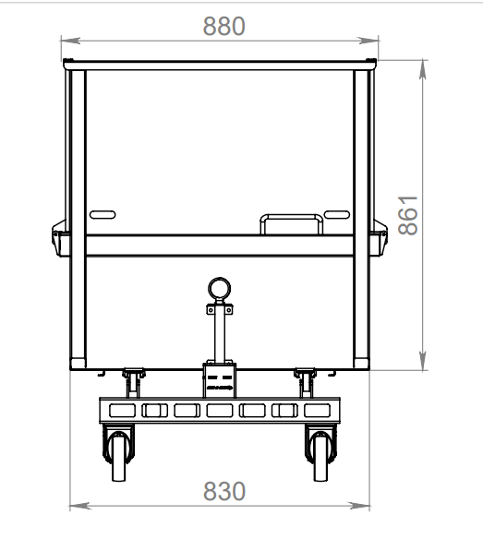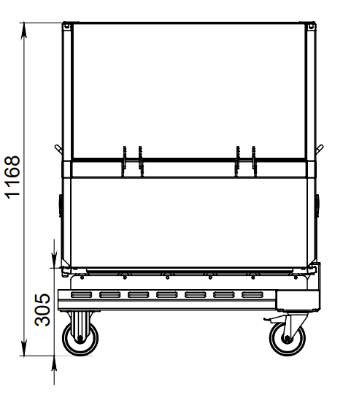
5.3. | Autoclave Baskets for Stand-Up Pouches | 24 units | Basket for autoclaving stand-up packs:  - Material Aisis 304;  - Wheels for the trolley (wear-resistant plastic), with bearings;  - Small wheels made of material (wear-resistant plastic), which do not deform and can easily push the basket onto the trolley.  - The lower middle part of the basket is separately liftable, does not deform, does not bend. withstands 350kg.  - Equipped with 2 locking pins (one on each side)  - Equipped with 22 trays;  - Each tray has 12 rows, where 5 stand-up packs can be placed in each row;  Tray dimensions: 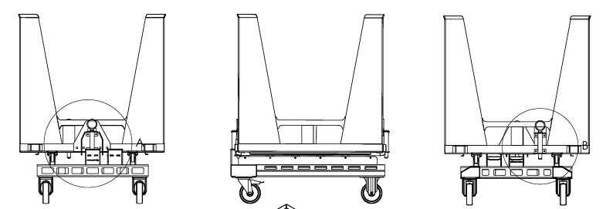  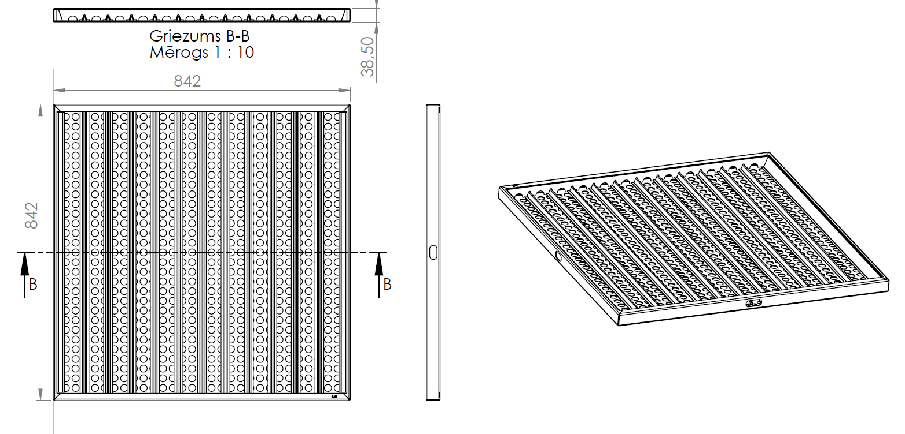
Lot No. 6
6.1. | Production Process Control and Data Acquisition System | 1 | A complex of production equipment with integrated measuring devices and sensors that accurately record the dosed raw materials and control the recipe parameters – temperature, volume, cooking time, etc. The equipment automatically records the produced products, separating the rejects. It is integrated with laboratory data and does not allow to continue production without positive confirmation. The equipment obtains data from production lines, performs product accounting and linking the used raw materials to batches, as well as records the consumed time and other resources used in order to calculate the cost price of the products.
Lot No. 7
7.1. | Multifunctional grinder | 1 | STEPHAN Microcut MCH 150 FS high (K) or equivalent.  A machine that combines efficient mixing, fine cutting and emulsification in a simple operation, requiring minimal space.  Designed for mincing fish fillets, meat.  Approximate dimensions of the machine +/- 5% (from the floor to the product discharge outlet must not be less than 850 mm).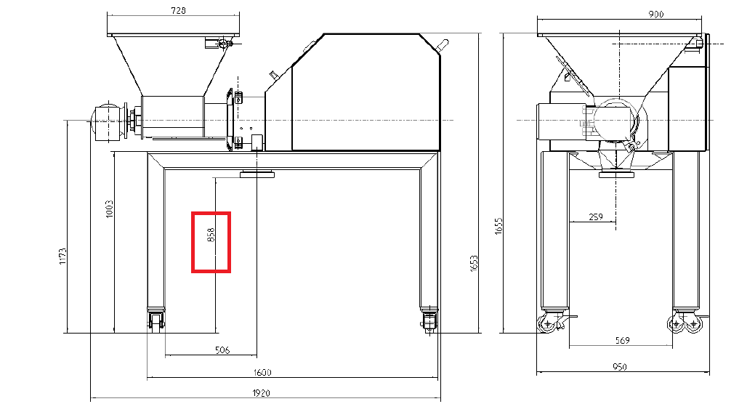  Equipped with:  - Feed screw driven by a gear motor.  - Control elements for manual operation  - Rotor and stator (first and second stage)  - Discharge disc  - Loading hopper with grid  - High base frame on 4 wheels  Machine indicators  - Hopper volume 100 l  - Productivity 4500 kg/h  Drives:  - main motor MCH 150 kW 30  - gear motor kW 1.5/2.2  Connections: product discharge outlet DN 125
7.2. | Steam exhaust hood system | 1 | The hood consists of:  - Exhaust hood 2500*2500*450  - Roof fan DVN 500D4IE3 7500m3/h Pa100 120*  - Non-return valve  - Frequency converter  - Speed ​​regulator  - Throttle valve with electric drive  - Air duct size 500  The exhaust is discharged to the roof (roof slope 9*)  There are three switching positions (off, on, auto)  It is possible to take a signal from the cooking pot to open the valves and turn on the exhaust automatically.  Include delivery, installation, personnel training
7.3. | Product filter | 1 | Filter description:  - Material stainless steel 316  - The filter consists of two sections;  - 2.5 mm filtration;  - It is possible to use one section without a filter;  - Maximum pressure 10bar  - DN 80 EPDM  - Intended for use in food production  - Mounted on a frame  - Attached to the boiler outlet pipe  - Include delivery, installation, personnel training  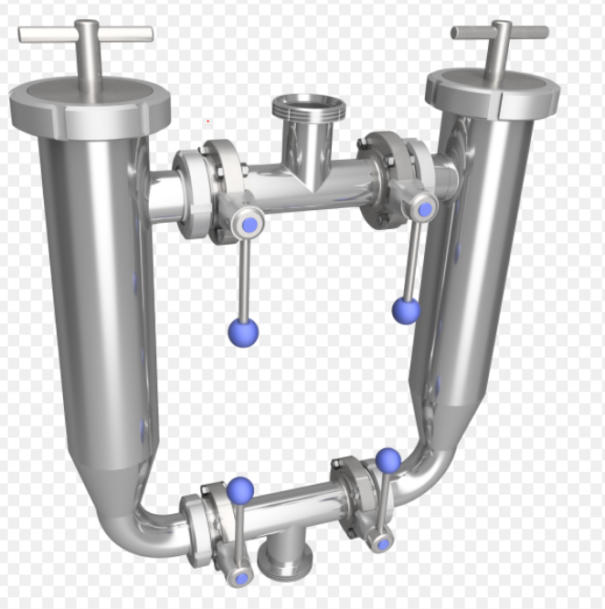
7.4. | In-line metal detector | 1 | Tubular metal detector.  - A metal detector is required for detection in a stream, mostly of a homogeneous product. With a few exceptions, where there are small pieces of oats, rice or other cereals.  - equipped with a closed container/tank for rejected product.  - located on a separate frame;  - detection chamber diameter 50 mm  - separation method- automatic diverting valve  - Sensitivity fe 0.5 mm, sus304 1.2 mm  - compressed air parameters >=0.5Mpa  - detection chamber material – food grade trflon tube  - power supply AC220V
7.5. | Buffer tank | 1 | Double-walled tank with mixer, for accumulating portions of the cooked product and evenly mixing various additives throughout the product volume, with the possibility of cooling and temperature maintenance (88C). Cooling with flowing water.  We offer to make a buffer tank  • Working volume 1300 liters  • Full volume 1680 liters  • Material in contact with the product AISI316  • Material not in contact with the product AISI304  • Working pressure up to 1 bar  • Temperature max 95 degrees  • Spiral mixer with scrapers  • Burgmann seal on the mixer shaft  • Heat exchange sleeves on the cylinder and lower cone  • Two CIP heads at the top and one at the bottom. The upper ones rotate 360*  • Hatch with sensor at the top  • Safety valve  • Connections and sensor sockets 3 pcs.  • Thermal insulation rock wool 75 mm  • Cladding 2mm AISI304 GRID240  • Four legs with height adjustment  • Internal diameter 1270 mm  • Cylinder height 1000 mm  • PED certificate  - mixer of appropriate shape, which ensures uniform mixing of additives (product pieces up to 15 mm) throughout the product volume.  - Equip with a control panel;  o Provide with the necessary fittings for CIP connection.  o Inclination angle of the lower part of the tank: not less than 10°.  - Using appropriate pipelines, valves and connecting elements, ensure product supply from the buffer tank to the product pump;  - Using appropriate pipelines, valves, connecting elements, wires, etc., ensure connection of the buffer tank with communications for the following energy carriers: water (from the room where the pressure boosting pumps are located); steam (from steam collector); compressed air (from compressor room); electricity (from electrical switchboard);  Include delivery, installation, personnel training.
7.6. | Product pump | 1 | - - Productivity: not less than 1000 kg/h  - - Product temperature: from 20- 95 °C  - - Product flowability: from 0.5cm/ bostrick  - - Pumpable particle size: not less than 15mm.  - - Material: stainless steel, for contact with food products;  - - Stainless steel mounting frame  - - Using appropriate pipelines, valves and connecting elements, ensure product supply from the pump to the filler;  - - Can be integrated into the CIP system  - Include delivery, installation, personnel training.
7.7. | Doypack filling machines | 2 | Equipment for automatic packaging of products in “doypak”: in a closed, plastic package with a flat base (multiple, welded seam construction with a folded base, product positioning in a vertical position) with a threaded “neck” at the top, for screwing on the cork.  Composition:   Packaging material feeding system: 1 pc.   Rotary table: 1 pc.   Product storage tank with level sensors: 1 pc.;   Filling pumps 2 pcs.;   Filling valves 2 pcs.;   Vibrating system for feeding caps/corks 1 pc.;   Screwing heads 2 pcs.;   Output conveyor 1 pc.;   Equipment base/frame 1 pc.  Complies with the following technical parameters:   Packaging options:   from 40ml. up to 250ml DP;   Productivity 80 pcs./min; 110ml packaging filled with water;   Electric power not more than 10kW;   Maximum filling temperature not less than 95C;   Dimensions must be included: width 2800mm; length 3300mm; height 2600mm, excluding communications;   Include delivery, installation, installation, personnel training;   Provide a place for a marking printer;   Using appropriate pipelines, valves, connecting elements, wires, etc., ensure connection to communications for the following energy carriers: water (from the room where the pressure boosting pumps are located); steam (from the steam collector); compressed air (from the compressor room); electricity (from the electrical switchboard).  Include delivery, installation, installation, personnel training.
7.8. | Marking printer/ Coding printer/ Inkjet printers | 2 | Inkjet printer:   Contactless printing   Number of lines: not less than 3 lines;   Automatic print head self-cleaning   IP53;   Prints up to three lines (25 points wide) with various print formats, including logos, barcodes, automatic serial numbering / batch coding and real-time recording;   Jet size 60 microns;   Pipe length 3 meters;   Stainless steel body;   Ink volume (Reservoir): 1.2 liters (automatically measured);   Ink durability (printed containers will be placed in an autoclave);   Solvent volume (Reservoir): 1.2 liters;  Equip with a stainless steel (ASI304) frame, appropriate to the dimensions of the device, ensuring work at the keyboard at a height of 1100mm (center point of the keyboard) from the floor.
7.9. | Stand-up pouch loading stations | 2 | Technical characteristics:  - Load capacity: not less than 350 kg  - Shelf movement speed: up to 0.1 m/s (6 m/min).  - Shelf positioning and fixing: With the help of a pedal.  - Working environment +5…+40°C;  - Table top in the width of two rack baskets;  - Using appropriate pipelines, valves, connecting elements, wires, etc., ensure connection to communications for the following energy carriers: electricity (from the electrical switchboard).  Include delivery, installation, personnel training.
7.10. | Weighing system for dosing containers | 2 | Material: Grade 304 stainless steel construction.  Finish: Stainless steel  Intended for: 200 litre Eurobins - DIN9797 standard  Maximum load: 350 kg including Eurobin  Operation: Manual loading and unloading,  Pneumatic lifting and lowering with push buttons  Power supply: 240 V single phase 50 Hz, 13 amp.  Air supply: 6 bar (dry and clean filtered)  Operation: Manual loading, unloading and lifting to weighing position  Indicator housed in stainless steel housing  Control panel rated IP69K  Mounting: Free standing leveling feet.  Footprint: 1040 mm wide x 780 mm high x 975 mm deep  Documentation: CE documentation and manual.
Lot No. 8
8.1. | Climate Control System | set | The system maintains optimal temperature, reduces heat load. Consists of:  - Duct type air conditioner 3 pcs (total capacity 100kw)  - Condensate outlets  - Freon pipes, insulation, freon  - Cover panels  - Electrical installation materials  - Assembly materials  Using appropriate pipelines, valves, connecting elements, wires, etc., ensure connection to communications for the following energy carriers: electricity (from the electrical switchboard), sewage outlet.  Include delivery, installation, personnel training.
Lot No. 9
9.1. | High-Performance Warehouse Reach Truck | 1 | - Warehouse reach truck for intensive high-level operations  - Equipped with lithium-ion batteries  - Ergonomic cabin with intuitive functions for operator comfort  - Operator interface with easy-to-use touch screen display  - Lifting speed: with load 0.57 m/s  without load 0.92 m/s  - Battery type Lithium-ion, 300 Ah  - Battery compartment 347 mm+/-2mm  - Battery arrangement on rails  - Mast 3-stage - 9500 mm with free lift, mast height when folded h1=3400mm +/- 5mm  - Distance between support forks 900 mm  - Equipped with support wheel  - Hydraulic control - separate levers  - Steering, degrees - 360°  - Seat - high backrest, headrest  - Equipped with operator overhead guard  - Fork length 1150 mm  - Forks with side shift  - Fork tilt - 4° up, 2° down  - Manual in Latvian  - Load guard 1000 mm  - Battery charger included
9.2. | Motorized Pallet Truck | 1 | Motorized pallet truck – motorized warehouse equipment designed for transporting pallets over longer distances. It is used for loading, unloading and moving goods in warehouses, production facilities or cargo receiving areas.  - Folding platform for intensive use over long distances  - Safety side guards  - Speed ​​control in turns  - Speed ​​control- Transistor, 8 km/h  - Battery type- Lithium-ion, 210 Ah +/- 5Ah  - Steering- power steering  - Access/start- PIN code keypad  - Drive wheel- with improved grip, width 70 mm +/-2mm  - Guards- installed guards  - Platform - Standard folding  - Fork width - 570 mm +/-3mm  - Fork length - 1150 mm +/- 3mm  - Fork wheels- One wheel on the forks, for heavy loads  - Support wheel- Vulcolan or equivalent, one wheel, diameter 125 mm  - Regulations-CE  - Manual in Latvian  - Speed ​​reduction button  New communications will be created to ensure the operation of the equipment: electricity for charging stations.

SIA “Lat Eko Food”
Chairperson of the Board
Egija Martinsone

*THIS DOCUMENT HAS BEEN SIGNED USING A SECURE ELECTRONIC SIGNATURE AND INCLUDES A TIME STAMP

