TECHNICAL SPECIFICATION
for participation in Procurement ID No. 24022026-01

No. | Equipment name | Quantity | TECHNICAL SPECIFICATION
Lot No. 1
Include delivery, installation, commissioning and personnel training.
1.1. | High-lift warehouse truck for intensive operation | 1 | - High-lift warehouse truck for intensive operation  - Equipped with lithium ion batteries  -Ergonomic cab with intuitive functions for operator convenience  - Operating interface with easy-to-use touch screen display  -lift speed: 0,57 m/s laden  unladen 0,92 m/s  - Battery type: lithium-ion, at least 300 Ah  - Battery compartment: 347 mm +/- 5 mm  - Battery arrangement: on rails  - Mast: 3-stage, 10,000 mm, with free lift; collapsed mast height h1 = 3,887 mm +/- 5 mm  - Distance between support forks: 900 mm  - Equipped with support wheel  -Hydraulic control- separate levers  -Steering, degrees - 360°  - Seat: high backrest and headrest  - Equipped with operator's headguard  - Fork length: 1,150 mm  - Forks with side shift  - Fork tilt: 4° upwards and 2° downwards  - Manual in Latvian  - Load backrest: 1,000 mm  - Automatic fork tilt return to zero position  - Automatic side-shift return to zero position  - Blue LED safety light  - Height indicator  - fork positioning laser  - camera system  - DC/DC converter 48V12V, with output in the panel  - Battery charger included
1.2. | Warehouse equipment - powered pallet truck | 1 | is a motorised warehouse machine designed to move pallets to longer distances. It is used for loading, unloading and handling of cargo in warehouses, production workshops or cargo acceptance zones.  - Fold-down platform for intensive long-distance use  Safety side guards  - Speed control in turns  - Speed control- Transistor, 8 km/h  - Battery type: lithium-ion, 210 Ah +/- 5 Ah  - Steering: power-assisted  - Access/start-up: PIN-code keypad  - Drive wheel with improved traction, width 70 mm +/- 2 mm  - Guards- installed guards  - Platform: standard fold-down type  - Fork width: 570 mm +/- 3 mm  - Fork length: 1,150 mm +/- 3 mm  - Fork rollers: one heavy-duty roller per fork  -Support wheel- Vulcolan or equivalent, one wheel, diameter 125 mm  - CE marking  - Manual in Latvian  - Speed-reduction button
Glass-container packaging line set
Lot No. 2
2.1. | Semi-automatic basket unloading line | 1 | Semi-automatic basket unloading line - jars from autoclave baskets are placed on the packing line conveyor.  Automatic discharge of the jars from autoclave baskets.  Line speed 9000 pcs/h  Baskets unloaded from above (basket height: 1,168 mm)  The jars shall be transferred to the labelling-line conveyor.  Jar dimensions:  Basket dimensions:  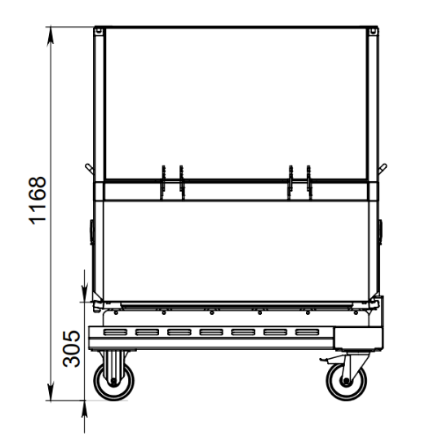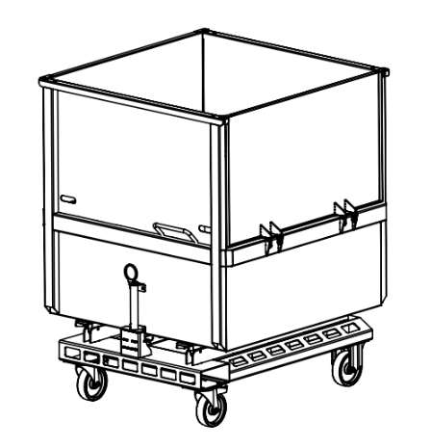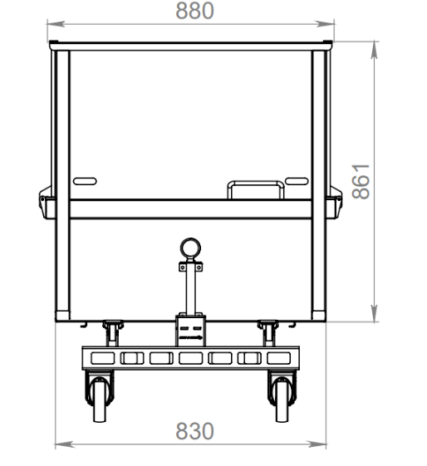  New communications will be created for the operation of the equipment: electricity, compressed air.  Include delivery, installation and staff training.
  No. | Jar description | Jar dimensions
   |  | Diameter height
  1 | Jar 130 ml (PT51) | 60,5 | 69,7
  2 | Jar 190ml (PT51) | 61+/-1,3 | 98+/-1
  3 | Jar 200ml (PT51) | 60+/-1,3 | 106,8+/-1
  4 | Jar 200ml (TO66) | 70+/-1,4 | 75+/-1
  4 | Jar 200ml (TO66) | 69,5 | 75,5
  5 | Jar 220 ml (PT51) | 60,9 | 108,5
  6 | Jar 240 ml (TO66) | 71+/-1,4 | 90+/-1
  7 | Jar 240ml, 250g (PT51) | 61+/-1,3 | 115+/-1
  8 | Jar 265ml (TO66) | 71,5+/-1,4 | 104,8+/-0,8
  9 | Jar 380 ml (TO66) | 73+/-1,4 | 124+/-1
  10 | Bottle 0.250 l (TO43) | 62,5+/-1,3 | 137,8+/-1,2
  10 | Bottle 0.250 l (TO43) | 62,5+/-1,2 | 137,8+/-0,8
  11 | Bottle 0.3 l (TO43) | 61,2+/-1,2 | 181+/-1,3
  11 | Bottle 0.5 l (TO43) | 75,+/-1,4 | 216+/-1,5
  12 | Bottle 0.5 l (TO43) | 74,5+/-1,4 | 212+/-1,5
2.2. | Glass-container dryer | 1 | The apparatus is designed to blow the moisture of the glass containers after the sterilization process. Blowing process: with the help of air knives placed at an angle to ensure the removal of drops of water from the glass containers.  The position of the air knives shall be adjustable to allow them to be adapted to each type of container. The structure is easy to move and easy to service.  -Equipment yield up to 9000 pieces/h (150 pcs./min)  - Conveyor speed (adjustable),  - Using appropriate pipes, valves,  The length of the conveyor shall be such that the jars can be taken from the unloading station, dried and transferred to the x-ray machine.  Connecting elements, wires, etc., to provide connection to communications for the following power carriers: electricity (from the power switchboard).  Include delivery, installation and staff training.
2.3. | Coding printer | 1 | Inkjet printer:  - Non-contact printing  - Number of rows: not less than 3 rows;  - Automatic self-cleaning of print head  - IP53;  - prints up to three lines (25 point width) with different print formats, including logos, bar codes, automatic serial numbering / batch coding and real-time recording;  - Nozzle size: 60 microns;  - Umbilical length: 3 metres;  - Stainless-steel housing;  - Ink volume (Reservoir): 1,2 litres (automatically measured);  - Ink resistance: suitable for printed containers subsequently processed in an autoclave;  - Volume of solvent (Reservoir): 1.2 litres;  Equipped with stainless steel (ASI304) frame, appropriate equipment dimensions, ensuring work on the keyboard at 1100mm height (the middle point of the keyboard) from the floor.
Lot No. 3
3.1 | Labelling machine | 1 | - You can apply 2 labels at the same time (base label, label label and label on bottle neck).  - option 2 labels (base label, label label)  -Line speed 9000 pcs per hour.  - Using appropriate pipes, valves, connecting elements, wires, etc., to provide connection to communications for the following energy carriers: compressed air (from compressor room); electricity (from electricity distribution cabinet).  Include delivery, installation and staff training.
Lot No. 4
4.1. | Automatic tray-packing and shrink-wrapping line | 1 | •Automatic packing machine which automatically supplies a cardboard tray and places the necessary amount of jars in it (Annex No 1);  •The machine shall be equipped with a heat tunnel that shrink-wraps the jars placed on the tray;  •The readjustment of the lines has mechanisms that change the width of all lines at the same time (in 4 places or less) by cutting so that the appropriate width of the jars can be applied.  •Film application mechanism format change control is from the equipment control panel.  Equipment dimensions:  •Length not exceeding 10 m  •The width does not exceed 1.6m  •Height not exceeding 2.5m  Resources required for the installation:  •Air consumption per cycle 20nl at 6bar
No. | Jar description | Jar dimensions |  | TRANSPORT PACKAGING - shrink film
No. | Jar description | Diameter in mm | Height in mm | Number of units per package | cardboard tray: yes/no | label on transport package | Position of label on transport package
1 | Jar 130 ml (PT51) | 60,5 | 69,7 | 6 | is | is | on top or side
2 | Jar 190ml (PT51) | 61+/-1,3 | 98+/-1 | 6 | is | is | on top or side
3 | Jar 200ml (PT51) | 60+/-1,3 | 106,8+/-1 | 6 | is | is | on top or side
4 | Jar 200ml (TO66) | 70+/-1,4 | 75+/-1 | 6 | none | is | on top or side
4 | Jar 200ml (TO66) | 70 | 75 | 12 | is | is | on top or side
4 | Jar 200ml (TO66) | 69,5 | 75,5 | 6 | is | is | on top or side
5 | Jar 220 ml (PT51) | 60,9 | 108,5 | 6 | is | is | on top or side
6 | Jar 240 ml (TO66) | 71+/-1,4 | 90+/-1 | 6 | none | is | on top or side
6 | Jar 240 ml (TO66) | 71+/-1,4 | 90+/-1 | 6 | is | is | on top or side
7 | Jar 240ml, 250g (PT51) | 61+/-1,3 | 115+/-1 | 6 | is | is | on top or side
8 | Jar 265ml (TO66) | 71,5+/-1,4 | 104,8+/-0,8 | 6 | is | is | on top or side
9 | Jar 380 ml (TO66) | 73+/-1,4 | 124+/-1 | 6 | none | is | on top or side
9 | Jar 380 ml (TO66) |  |  | 12 | is | is | on top or side
10 | Bottle 0.250 l (TO43) | 62,5+/-1,3 | 137,8+/-1,2 | 6 | is | is | on top or side
10 | Bottle 0.250 l (TO43) | 62,5+/-1,3 | 137,8+/-1,2 | 6 | none | is | on top or side
11 | Bottle 0.3 l (TO43) 171731 Ketchup O-I | 61,2+/-1,2 | 181+/-1,3 | 6 | none | is | on top or side
11 | Bottle 0.5 l (TO43) 175278 Ketchup O-I | 75,+/-1,4 | 216+/-1,5 | 6 | is | is | on top or side
11 | Bottle 0.5 l (TO43) 175278 Ketchup O-I | 75,+/-1,4 | 216+/-1,5 | 6 | none | is | on top or side
11 | Bottle 0.5 l (TO43) 175278 Ketchup O-I | 75,+/-1,4 | 216+/-1,5 | 12 | is | is | on top or side
12 | Bottle 0.5 l (TO43) SE00905006057 Ketchup Vetropack | 74,5+/-1,4 | 212+/-1,5 | 6 | none | is | on top or side
12 | Bottle 0.5 l (TO43) SE00905006057 Ketchup Vetropack | 74,5+/-1,4 | 212+/-1,5 | 6 | is | is | on top or side
12 | Bottle 0.5 l (TO43) SE00905006057 Ketchup Vetropack | 74,5+/-1,4 | 212+/-1,5 | 12 | is | is | on top or side

4.2. | Pallet wrapper | 2 | - Separate setting of upper and lower reinforcement wraps  - Pallet height detected by photoelectric sensor  -The speed of the cornering table is controlled by a variable frequency drive from 5 to 10 rpm  - Sensor-controlled rotation stop  - Safety photoelectric sensor  - Uniform start and stop of turn controlled by variable frequency drive  - Load capacity: at least 1,000 kg  - Turntable diameter: 1,650 mm  - Wrapping height: 2,100 mm  -Max. cargo dimensions 1200 x 1000  - Power supply: 230 V, 50 Hz  - Film stretching function
4.3. | Compressors for compressed-air supply | 2 | The compressor provides for steady, sufficient air pressure in the existing and new air duct. Compressor:  - Create connections from two places to the existing air line, track length 105m (include pipes, valves, connection points)  - Provide air connection locations 30 pcs  - Equipped with filters so that the oil does not enter the air system  - Equipped with a system where you can divert the warm air flow-winter during the room, during the summer outside  - The compressor oil used meets the requirements of the food industry  - Screw type compressed air compressor  - Rated electric motor power 22 kW, 400/3/50 V/f/Hz  - Maximum consumable power at full operating load not more than 28 kW+/-1 kW  - Maximum final compressive pressure not less than 10 bar+/-0.5bar  - Maximum compressed air yield according to ISO 1217 measurement standard not less than 3,2 m3/min.+/- 0,1m3/min.  - Noise level not more than 72 dB by DIN ISO EN 2151  - The compressor shall be equipped with frost protection down to -10°C  - The compressor shall be filled with food-grade H1 oil (oil specification to be provided)  - The compressor must be equipped with a remote monitoring system so that you can see the compressor operating parameters remotely (via the WEB browser)  - Equipped with a frequency converter  - The compressor shall be equipped with an integrated refrigerant air dryer  - The compressor shall have an integrated pressure receiver with a capacity of at least 500 litres  - The compressor shall be equipped with a condensate oil separator  - Touchscreen equipment control panel in Latvian  - The equipment must have been manufactured in accordance with the following mandatory provisions of the Machinery Directive 2006/42 EC,  Electromagnetic Compatibility Directive 2014/30/EU, RoHS Directive 2011/65/EU  - It shall also respect:  Pressure equipment Directive 2014/68/EU  Low-voltage Directive 2014/35/EU  Directive 2014/29/EU on simple pressure vessels  - The equipment must be CE-marked  - Equipment dimensions not greater than 2036 x 915 x 1915 h +/-50mm  - Weight not more than 800 kg +/-5 kg
Lot No. 5
5.1. | Racking for the packaging workshop | 2 sets | Warehouse shelving system 500 pallet places (one set)  - 5 beam levels + floor  - the weight of pallets shall not be less than 800 kg;  - Frame height 9500 mm  - Length of beam 2.7 m  - Beam height: 125 mm  - shelves are equipped with racks and row guards;  - on shelves need to place load  load tables;  - racks galvanized;  - Beams painted  - Upright profile: 100 x 65 mm  - Upright thickness: 2 mm  - foot size 135 x 120 mm  - the thickness of the foot of at least 6mm or more,  - beam displacement step of not less than 50mm;  - working-aisle width: at least 3,200 mm;  - All load requirements are based on current European standards prEN15512 using a safety factor of 1,54 frames and beams.  - Include delivery, installation, personnel training.
CIP and hygiene line set
Lot No. 6
6.1. | CIP station for fish-processing and filling equipment | 1 | 1. Adding new tubes to existing CIP pipe ends on tanks for acid, alkaline and recovered water tanks  2. CIP line No 2 equipment  - Static foot water tank 650 liters 1 pcs.  - CIP pump - 2 5,5 kW 25m3/h 1 pcs.  - Filter on CIP line No. 2: 1 pc.  - Flow meter 1 pcs.  - Concentrated disinfectant dosing station in safety cabinet for line 2 1 pcs. And integration of existing pumps into the safety cabinet 1 pcs  - Steam control and vapour shut-off valves 1 pcs.  - Condensate valves 1 pcs.  - Tubular heat exchanger 1 pcs.  3. Process valves for CIP line No 2  - Butterfly valves, standard version of welding, automated with control unit and pneumatic drive DN 76.1; DN63,5; DN51; DN25 1 set for 316L quality line 2  - Automatic diaphragm valve with control unit and pneumatic drive DN15, chemical concentrate for dosing - 3 pcs.  - Manual butterfly valves: 1 set, AISI 316L, for line No. 2  4. Equipment for CIP line 2  - Temperature gauge PT-100 1 pcs.  - Pressure sensor for determination of level of static legs in tank 1 pieces.  - Flow sensor on line 2 1 pcs.  - Conductance sensor for line 2 1 pcs.  5. Combining the management system with CIP line 1 to simultaneously use two CIP lines (existing and new)  - New stainless steel control cabinet  - New Siemens PLC S7-1500 or analogue  - New Siemens HMI 15-inch Comfort or equivalent  - Reporting system for completed CIP cleaning cycles  6. Fully universal automatic valve block enabling interchangeability between two CIP lines and five equipment groups
6.2. | CIP lines to the cooking kettle and filler | 1 | 1. Construction of stainless steel for chemistry, pipe track for washing equipment  12 m from the CIP panel to the cooking kettle;  The exit pipes must have on top of the safety valves which open only on a specific chosen washing line.  24 m to the filler;  Allow for both supply and return lines;  Pipe diameter DN51  2. CIP reverse pumps 2 pcs  - Minimum yield 10 m3/h, 3 kW  - Pumps controlled by the CIP system  Include delivery, installation and staff training.
Lot No. 7
7.1. | Fixed equipment with washing systems where it is possible to wash with 2 foam washing agents. | set | Fixed washing system with pump and 4 satellites equipped with automatic hose winding coil assemblies (3 pcs. with 20m and 2 pcs. with 30m hoses, 2,5m connection hoses, low pressure foam valves or guns, fitted with wall screwed bracket) and a possibility to wash with 2 foam detergents. Set - Pumping station with a productivity of at least 200l/min at an input pressure of 2bar (3x400V/50Hz) or equivalent, 3 satellites per user and 1 satellite for 2 users (dual satellite). Connect the pump station to the total water network.  - including the connection of pump stations to 4 satellites, with stainless steel tubes of appropriate diameter. Master's length 40m, branches to satellites 20m (total of 4 satellites 80m)  Satellites shall have stainless steel cans holders 2x30kg 285x700mm or equivalent. It shall be possible to wash with 2 types of detergents.  - Using appropriate pipes, valves, connecting elements, wires, etc., to provide connection to communications for the following energy carriers: water (from the common system), electricity (from the electrical switchboard), signal exchange (between control units and pumps);  - System delivery, installation, connection and training of personnel.
Sterilisation system set
Lot No. 8
8.1. | Autoclaves | 3 | - Inner Diametr 1300;  - capacity six baskets;  - 2 doors (at one end basket loading, second discharge);  - door opening direction to be agreed upon conclusion of the contract;  - automatic loading and discharge of baskets;  - Steam working pressure 6bar (+/- 0,5 bar);  - compressed-air operating pressure: 6 bar (+/- 0.2 bar);  - electricity connection 380V;  - an output not exceeding 8 kW  - the autoclave has the possibility to connect 3 water pipes and 3 water-out pipes, which provide water flow to the relevant tanks for reuse of water;  - by means of appropriate ducts, valves, connecting elements, wires, etc., to ensure the connection of autoclaves to communications for the following energy carriers: water (from the room where pressure pumps are located, material- AISI 304 DN 50/60); steam (from the wall thickness of the vapour collector AISI 316 DN 114 3mm); compressed air (from the compressor room); electricity (from the electrical switchboard), condensate track (condensate collector and pump) from autoclaves back to the boiler AISI 316/304 DN 65/76;  - delivery, installation, connection to communications and staff training  - to integrate the existing autoclave into a common system;  - integrate cycle reports into the existing system.
Lot No. 9
9.1. | Autoclave baskets for glass containers | 30 pieces | Basket for autoclaving glass containers:  - Material: AISI 304;  - Wheels (wear-resistant plastic), with bearings;  -Small wheels of material (wear-resistant plastic) which do not deform and can easily push the basket on the trolley.  - The lower central section of the basket shall lift separately, shall not deform or bend, and shall withstand 450 kg.  - equipped with 2 locking pins (one on each side)  - intended for automatic loading and unloading of jars.  - the inner walls smooth, so as not to go into jars and damage the caps  - supplied with 430 separators made of material suitable for 121°C  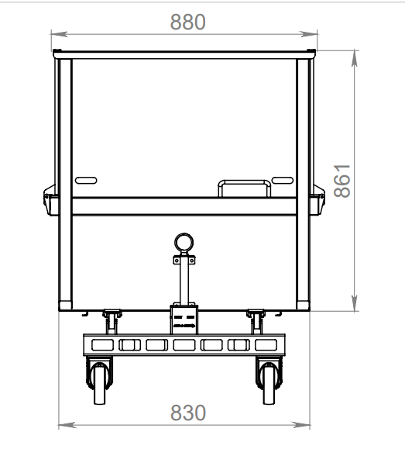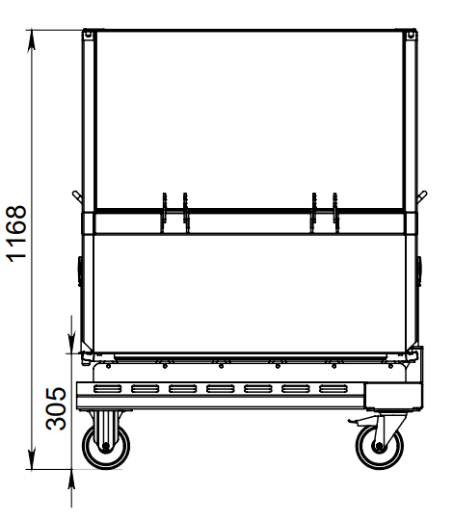
9.2. | Autoclave baskets for stand-up pouches | 24 pieces | Basket for autoclaving stand-up pouches:  - Material: AISI 304;  - Wheels (wear-resistant plastic), with bearings;  -Small wheels of material (wear-resistant plastic) which do not deform and can easily push the basket on the trolley.  - The lower central section of the basket shall lift separately, shall not deform or bend, and shall withstand 350 kg.  - equipped with 2 locking pins (one on each side)  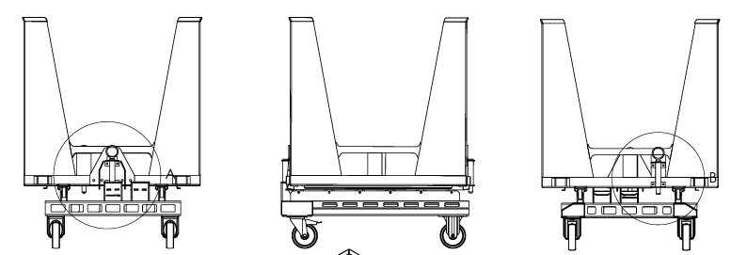  - equipped with 22 trays;  - each tray contains a row breakdown;  Tray dimensions:  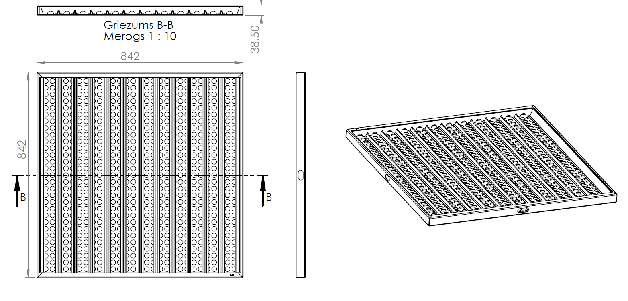
Filling line set
Lot No. 10
10.1. | Multifunctional grinder | 1 | STEPHAN Microcut MCH-D150 FS low or equivalent.  A machine that combines effective 2-stage mixing, fine cutting and emulsifying in simple operation, requiring minimal space.  Designed for grinding fish fillets.  Appliance dimensions +/- 5% (from floor to product discharge outlet must not be less than 740 mm)  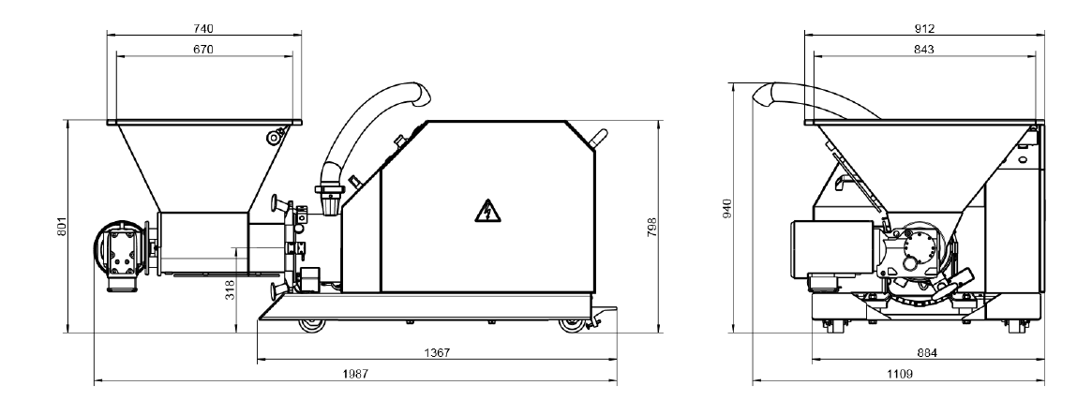  Equipped with:  - Feed screw powered by a reducer engine.  - Equipped with a pre-cutter  - Control elements for manual operation  - Rotor and stator (first and second stage)  - Discharge disc  - Loading funnel with grid  - frame on 4 wheels  Equipment parameters  - Hopper capacity: 100 l  - Productivity 4500 kg/h  Drives:  - main motor MCH-D 150: 45/55 kW  - geared motor: 1.5/2.2 kW  Connections: product discharge outlet DN 65
10.2. | Steam extraction hood above the cooking kettle | 1 | The extractor consists of:  - Extraction hood 2,500 x 2,500 x 450 mm  - Roof fan DVN 500D4IE3 7500m3/h Pa100 120*  - Reversing valve  - Frequency converter  - Speed adjuster  - Electrically driven throttle  - Air-duct size: 500 mm  Exhaust piped to the roof (roof slope 9*)  Three operating positions: off, on and automatic  The system shall accept a signal from the cooking kettle to open the valves and start extraction automatically.  Include supply, installation, personnel training
10.3. | Product filter | 1 | Filter description:  - Material: AISI 316  - The filter consists of two sections;  - 2,5 mm filtration;  - It is possible to use one section without a filter;  - Maximum pressure 10bar  - DN 80 EPDM  - For use in food production  - Mounted on a frame  - Connected to the kettle outlet pipe  - Include supply, installation, personnel training  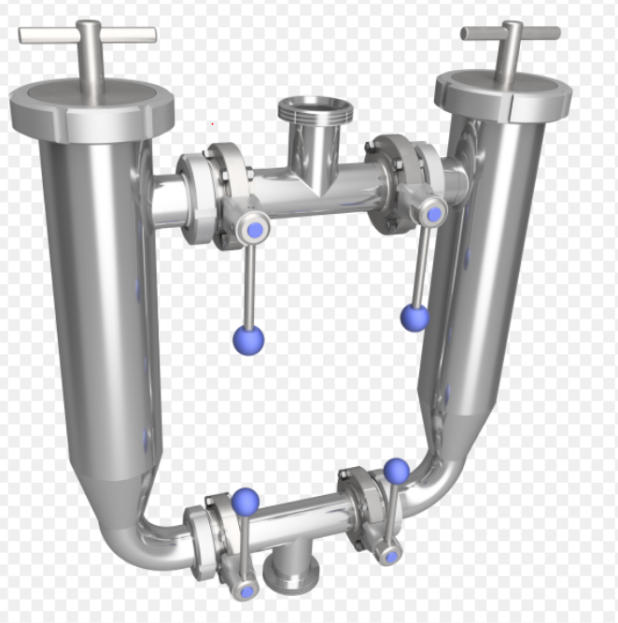
10.4. | Doypack (stand-up pouch) filling machine | 1 | Installation for automatic packaging of the product in the doypack: closed, plastic packaging (structure of several closed joints, vertical positioning of the product)  Composition:  - Feeding system for packaging material: 1pc.  - Equipped with printer installation location;  - Rotating table: 1 pc.  - Product storage tank with tiered sensors heated: 1 pc.;  - Filling pumps: 2 pcs.;  - Filling tips 2 pcs.;  - Steam injection system;  - Two-stage sealing;  - Sealed-seam cooling function;  - Position of discharge;  - Machine base/frame: 1 pc.;  - Siemens's management PLC  - Touch sensitive control panel;  Consistent with the following technical parameters:  - Packaging options:  - You can pack from 100 to 800gr.  - Pack sizes:  - Width 100-230 mm  - Height 150 -350mm  - Productivity 80 pcs/min; water filled 110ml wrappings;  - El. power not exceeding 6 kW;  - Maximum filling temperature: at least 95°C;  - Must fit into size (may not be larger): width 2700 mm; length 3800mm; height 2200mm, excluding communication;  - Include delivery, installation, installation, training of personnel;  - Provide space for the coding printer;  - Using appropriate pipes, valves, connecting elements, wires, etc., ensure connection with communication for the following energy carriers: water (from the room where pressure pumps are located); steam (from the vapour collector); compressed air (from the compressor room); electricity (from the electrical switchboard).  Include delivery, installation, installation, personnel training.
10.5. | Coding printer | 1 | Inkjet printer:  - Non-contact printing  - Number of rows: not less than 3 rows;  - Automatic self-cleaning of print head  - IP53;  - prints up to three lines (25 point width) with different print formats, including logos, bar codes, automatic serial numbering / batch coding and real-time recording;  - Nozzle size: 60 microns;  - Umbilical length: 3 metres;  - Stainless-steel housing;  - Ink volume (Reservoir): 1,2 litres (automatically measured);  - Ink resistance: suitable for printed containers subsequently processed in an autoclave;  - Volume of solvent (Reservoir): 1.2 litres;  Equipped with stainless steel (ASI304) frame, appropriate equipment dimensions, ensuring work on the keyboard at 1100mm height (the middle point of the keyboard) from the floor.
10.6. | Stand-up pouch loading station | 1 | Technical characteristics:  - Load capacity: at least 350 kg  - Shelf travel speed: up to 0.1 m/s (6 m/min).  - Shelf positioning and locking: by pedal.  - Working environment +5...+40°C;  - Tabletop width suitable for two stand-up-pouch baskets;  - Using appropriate pipelines, valves, connecting elements, wires, etc., ensure connection to communications for the following energy carriers: electricity (from the electrical switchboard).  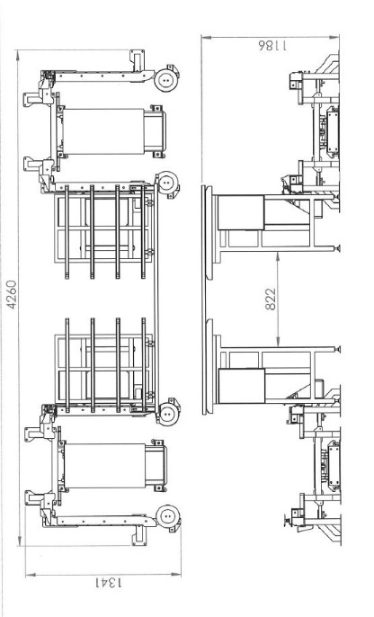  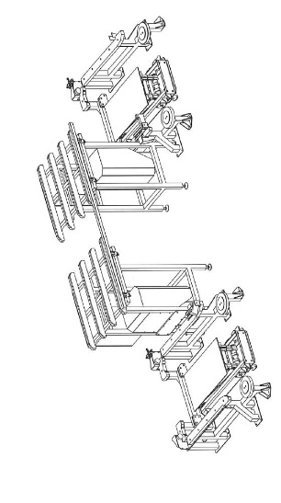  Include delivery, installation and staff training.
10.7. | Weighing system for dosing containers | 2 pieces | Material: Class 304 stainless steel construction.  Finishing: stainless steel  Intended: 200 litres Eurobin - DIN9797 standard  Maximum load: 350 kg including Eurobin  Operation: manual loading and unloading,  Pneumatic lifting and lowering with push-buttons  Power supply: 240 V single phase 50 Hz, 13 amp.  Air supply: 6 bars (dry and clean filtered)  Operation: manual loading, unloading and lifting at weighing position  indicator contained in a stainless steel housing  Control panel rated IP69K  Installation: free-standing levelling feet.  Footprint: 1,040 mm wide x 780 mm high x 975 mm deep  Documentation: CE documentation and manual.
Lot No. 11
11.1. | Quality-control X-ray unit for stand-up pouches | 1 | Purpose of the X-ray unit: detection of foreign bodies in stand-up-pouch packages whose absorption is higher than that of the product.  Product size: length 250mm, width 200mm, height 40mm or more  - Determination of solid foreign matter (glass 5mm, stone 4 mm, metal 1.6mm) in the product filled packaging  - equipped with a rejection mechanism and a closed compartment receiving packages in which foreign bodies are detected  - Rejection procedure test  Line speed:  Number of packages: 80 pcs./min or more,  Conveyor speed: min. 1,0 m/s or more  Include delivery, installation, installation, personnel training.
Lot No. 12
12.1. | Buffer tank | 1 | Double-walled tank with agitator for accumulating batches of cooked product and uniformly mixing additives throughout the product volume, with cooling and temperature maintenance at 88°C. Cooling by circulating water.  Buffer tank characteristics:  - Working volume 1800 litres  - Material in contact with product AISI316  - Material not in contact with the product AISI304  - Temperature max 95 degrees  - Mixer - helical  - Heat-exchange jackets on the cylinder and lower cone  - Two CIP heads at the top and one at the bottom; upper heads rotating through 360°.  - Top manway with sensor  - Connections and sensor sockets: 3 pcs.  - Thermal insulation: 75 mm mineral wool  - Cover 2mm AISI304 GRID240  - Four legs with height control  - a blender of the appropriate shape, ensuring the smooth incorporation of additives (pieces up to 15 mm) throughout the product volume.  - Equipped with control panel;  - Provide the necessary fittings for the CIP connection (3 m)  - Provide with the necessary fittings for receiving the product from the cooking boiler (3m);  - Angles of inclination of the lower part of the container: not less than 10°.  - Equipped with product pump:  - Productivity: not less than 1000 kg/h  - Temperature of product: from 20 to 95 °C  - Flowability of the product: from 0,5cm/ bostrick  - Size of the particles to be pumped: not less than 15 mm.  - Material: stainless steel, food contact;  - Stainless steel strengthening frame  - May be integrated into the CIP system  - Ensure the supply of the product from the buffer tank to the product pump by appropriate ducts, valves and connecting elements;  - Using appropriate pipes, valves, connecting elements, wires, etc., to ensure connection of the Buffer tank with communication for the following energy carriers: water (from the room where pressure pumps are located); steam (from the vapour collector); compressed air (from the compressor room); electricity (from the electrical switchboard);  Include delivery, installation and staff training.
Climate-control equipment set
Lot No. 13
13.1. | Climate-control system | set | Technical data of the internal unit (evaporator):  Quantity: at least 3 dual-discharge ceiling-mounted indoor units  Cooling capacity: at least 33.5 kW per dual-discharge unit at inlet air temperature +19.0°C and relative humidity 63.0%  Airflow: at least 8,640 m³/h per dual-discharge indoor unit  Fans for air exchange-No less than 6 fans for one two-flow internal unit. Fans must have a single-phase EC type, with power class A, control 0-10V, with IP class not lower than IP54. Fan operating range not higher than -25,0°C and not lower than +30,0°C Sound pressure (3m) shall not exceed 56db, an upward deviation of +2bd is allowed.  Defrosting: automatic  Connection: copper pipes  Evaporator casing: galvanised sheet steel with white powder coating. If another colour is offered, specify it in the tender and state whether it can be changed.  Control-Control controller for each of the 3 sets, with integrated automatic control that allows you to change temperature, switch off/on equipment, perform forced thawing, change other working parameters, perform basic function change  Provide and install suitable insulated copper piping and control-cable routes;  Supply and construction of a drainage system;  Provide for the assembly of internal and external equipment, as well as mains and other elements, fastenings, flaps, consumables and staff training;  All equipment and materials must be labelled, the marking must comply with the EU Directive on each element that will be used during construction must be attached to the Declaration of Conformity, Data Sheet  Technical data for the outdoor cooling unit:  Number- Not less than 3 outdoor units. At each internal block not less than 1 external unit  Voltage-Designed electric power output of each external block up to 380V, 32A, one external block not exceeding 14 200 W  Cold power-Total out-block power not less than 100 000 W  Pipeline metropolitan compliance-Ara equipment shall be capable of providing, by technical data, a minimum of 40m to an evaporator taking into account vertical elevation  External temperature compliance - Ensure continuous operation between -20°C and +35°C  The installation must be able to operate under the specified outdoor conditions without additional elements being installed.  Refrigerant: in accordance with applicable Cabinet regulations  Temperature modes - Appropriate temperature regime +18°+20°C  Outdoor-unit condenser cooling: axial fan; the use of water or any medium other than ambient air for cooling is prohibited.  Heat recovery: heat recovery from the outdoor unit will be considered an advantage if accompanied by a data table showing the additional equipment cost and annual user savings. The tender shall include a heat-recovery unit at the outdoor unit, terminating in shut-off fittings with integrated controls.

SIA “Lat Eko Food”
Chairperson of the Board
Egija Martinsone

*THIS DOCUMENT HAS BEEN SIGNED USING A SECURE ELECTRONIC SIGNATURE AND INCLUDES A TIME STAMP

